OutOfMemory (OOM) error troubleshooting:
- jvisualvm to observe OOM:
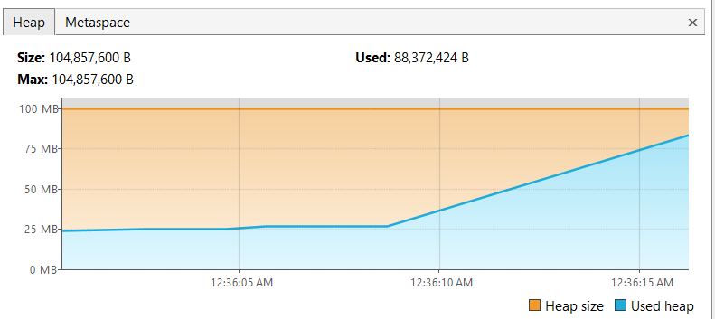
- Analyze heap dump:
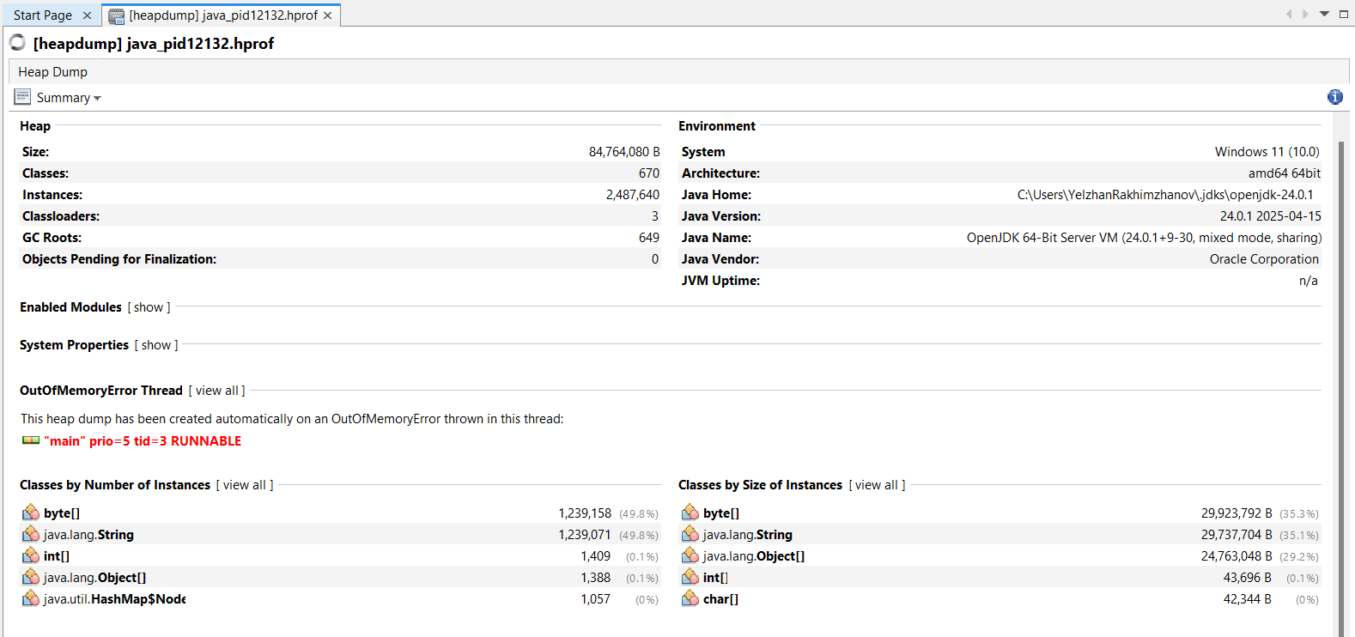
- OQL Queries:
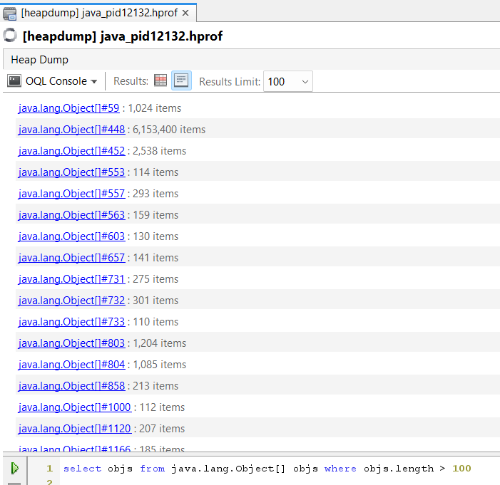
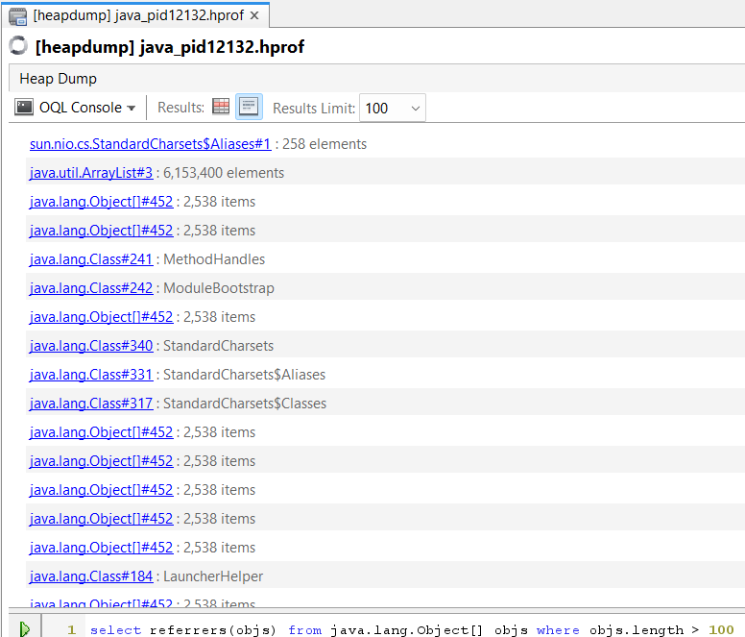
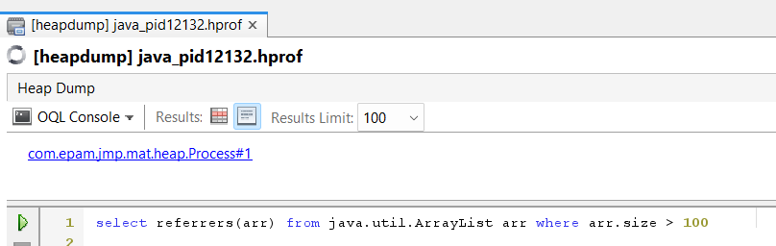
Deadlock troubleshooting
- Thread dump:
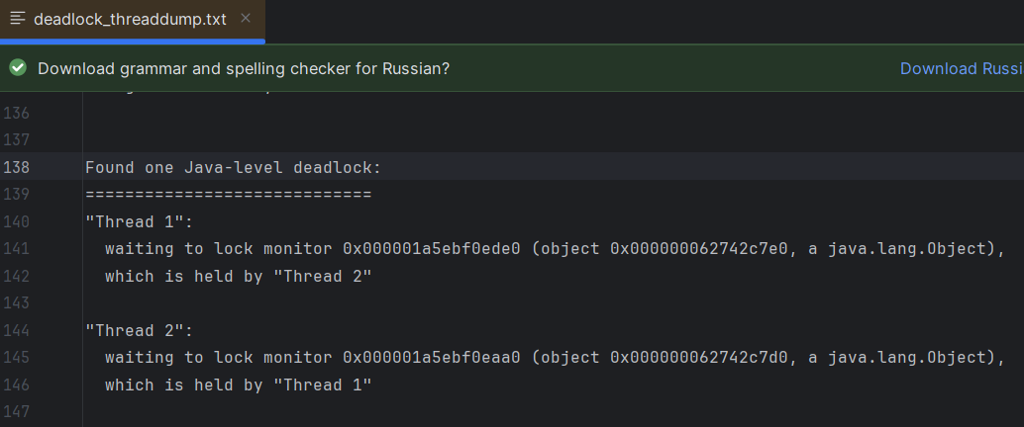
- VisualVM:
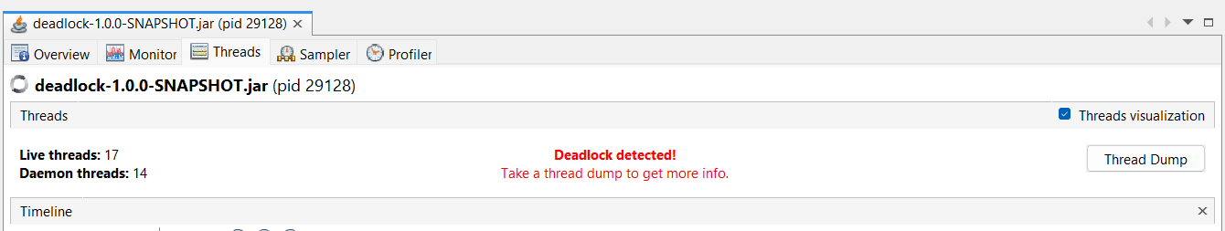

Remote JVM profiling
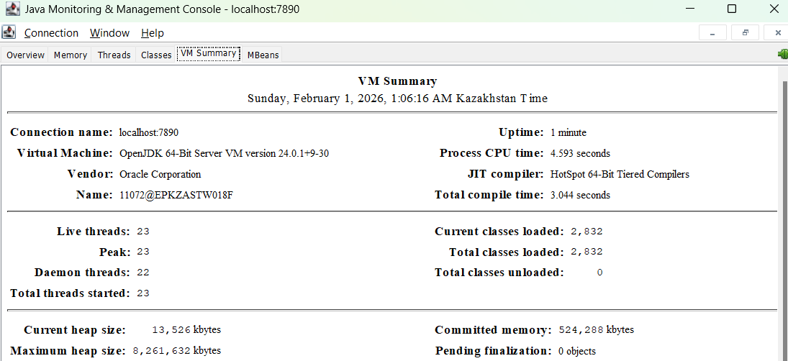
Inspect a Flight Recording
